Add an Existing Class to a Project:

For a one time use of a class:

Method 1: Copy the java class file into the SRC folder of your project
Change the associated package name to the package of your
Current project
Use the class in your project

If you have a class or a set of classes that you would like to use on many projects:

Method 2: Create your own Java Class Library

TOOLS … Library Manager

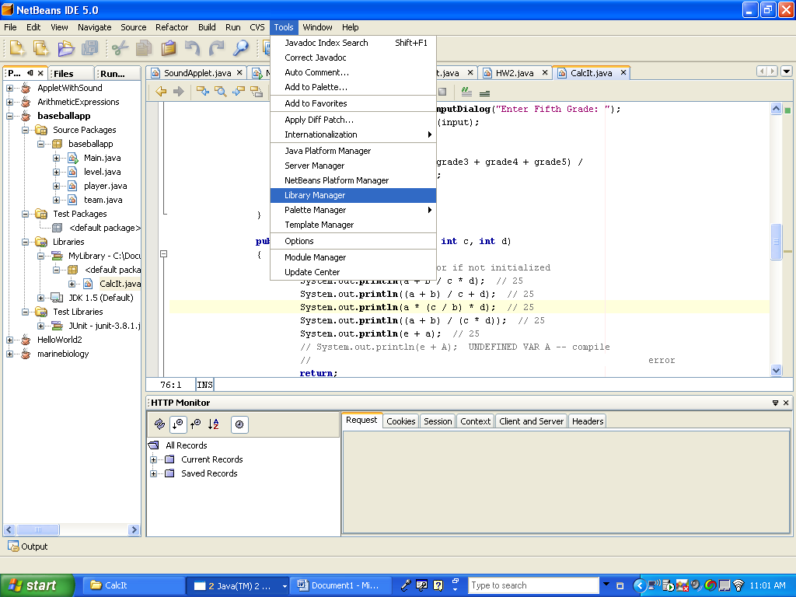

Create a NEW Library and give it a meaningful name

Then Click on the ADD JAR/Folder tab, locate the java file or files to add to this library
And add them to the list

Click OK and the Library is created

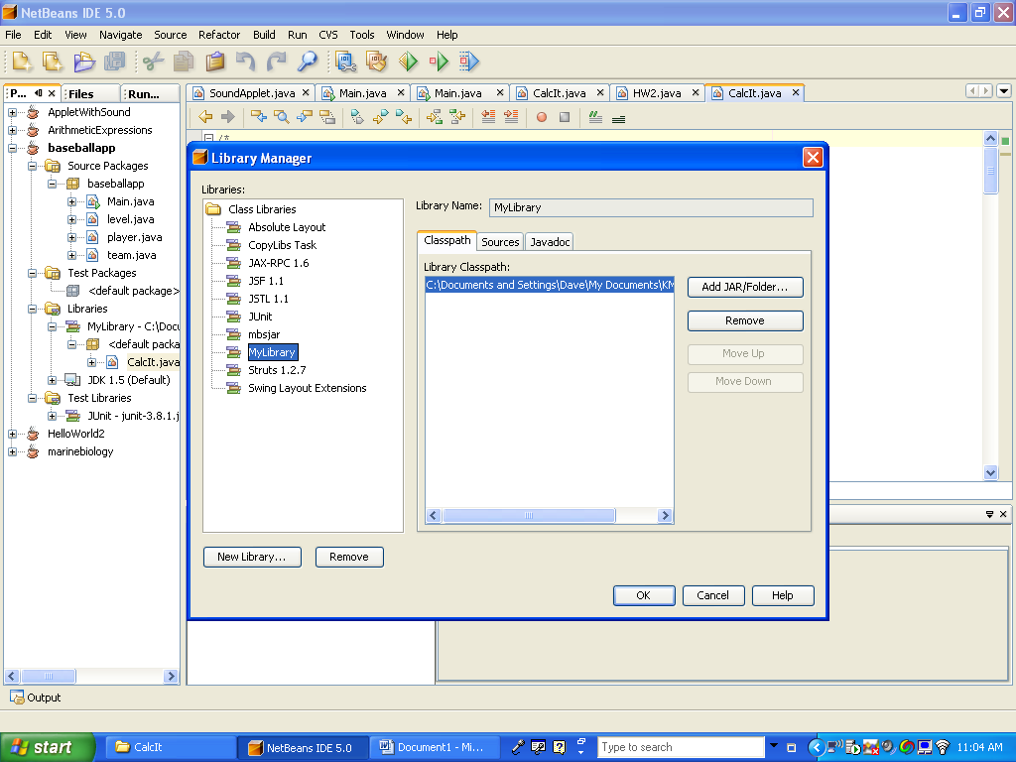

Now, add your library to a project RIGHT click on the Libraries folder in your project and select ADD LIBRARY

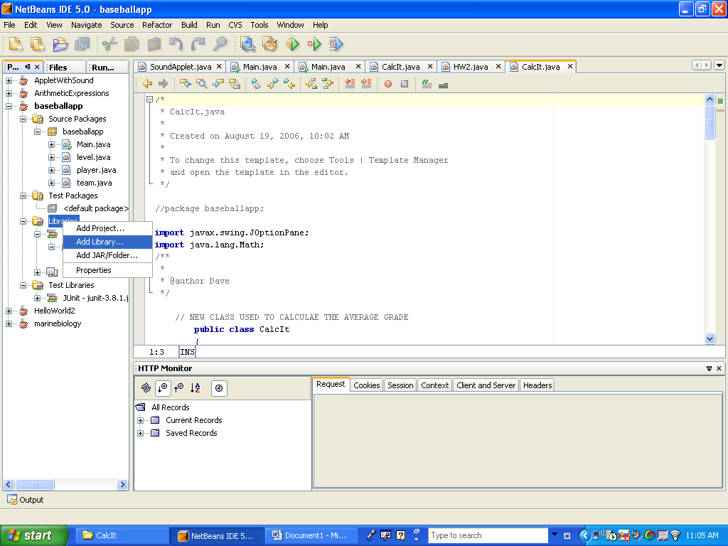

Now you can use the classes from the library in your project.

Changing the Current Project:

Right Click on the Project you want to make the current project

Select SET MAIN PROJECT

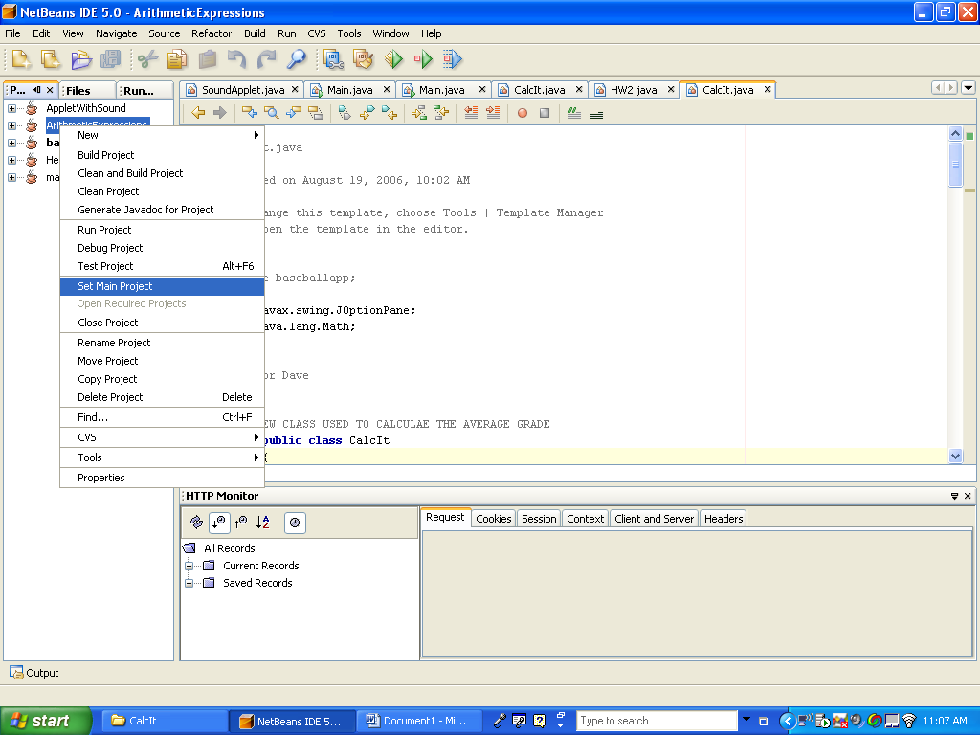

Move, Delete, Copy or Rename a Project:

Right Click on the Project and select Rename, Move, Copy or Delete the project

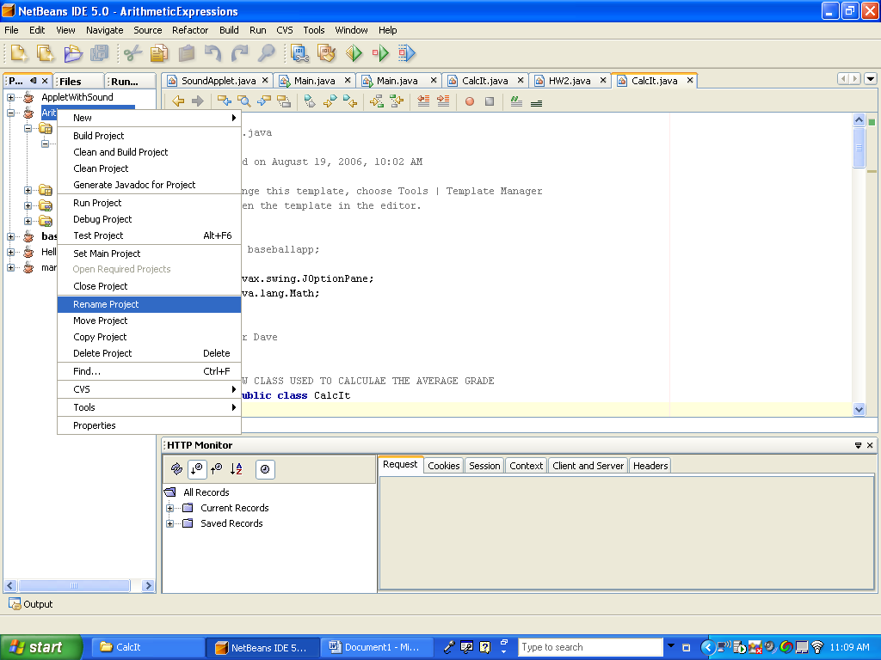

Create a Java Doc for Your Project:

Click on Build … Generate JavaDoc…

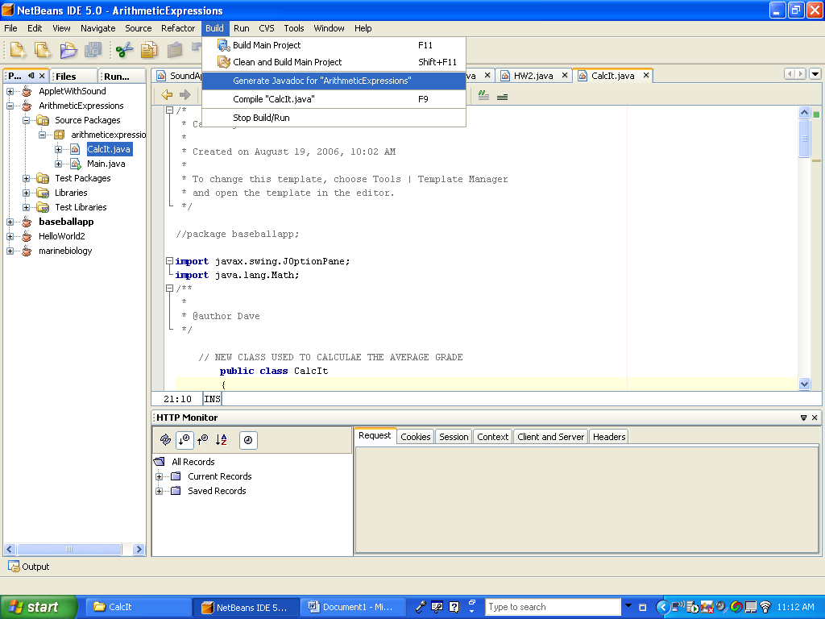

This generates a fully Functional JAVA DOC / HTML of your application

